2019 Myanmar Conference Manual
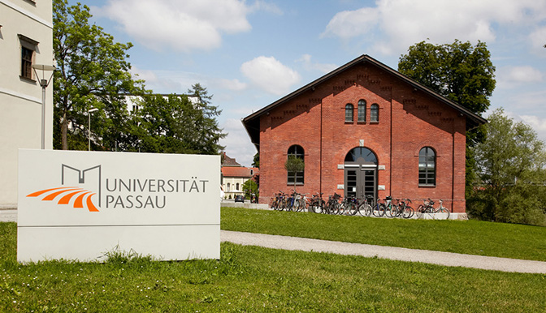
This manual serves as a guide for all guests and speakers visiting the 2019 Myanmar Conference at the University of Passau. We present basic information revolving around your stay to ensure a comfortable experience in Germany.
The venue for this event is the Innsteg-Aula (ISA) at the Innstr. 23. The building is directly by the river and close to all other university buildings.
In case you haven’t registered to the conference already, please make sure to do so HERE.
We will request special access to the university’s WiFi network, which you will be able to connect to 24/7 and around all university buildings. The relevant access information for the university network eduroam will be handed out to you directly at the conference reception.
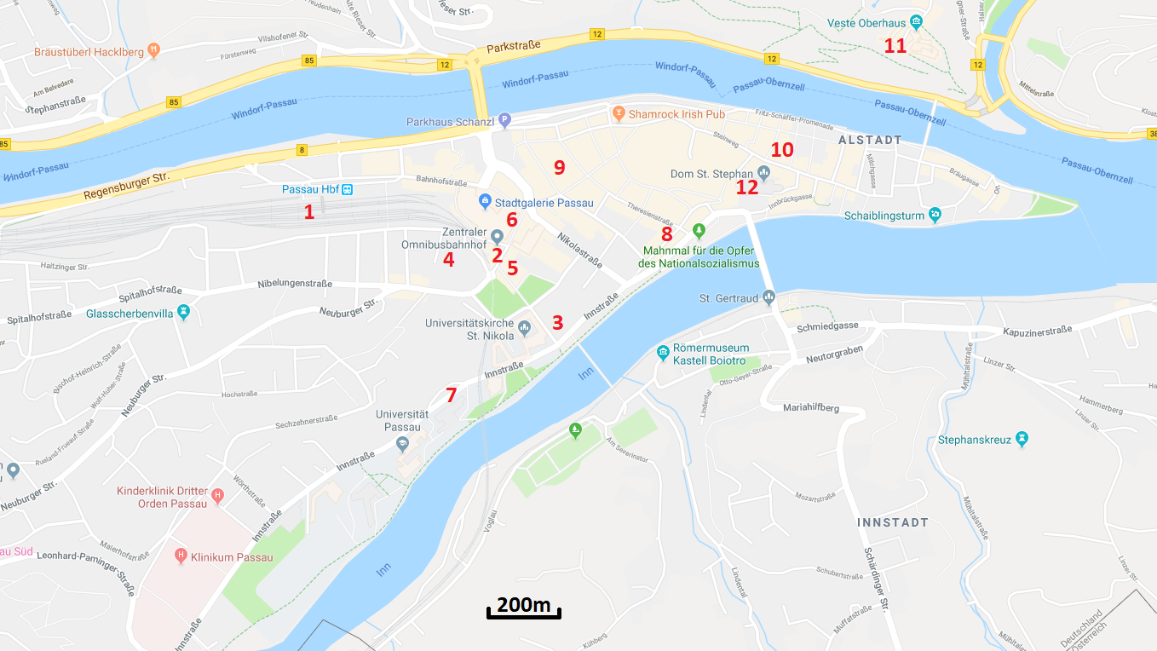

Central Overview of Passau
On the map you can find the following points of interest:
# | Name | Address
1 | Passau Main Train Station
2 | Central Bus Station
3 | University of Passau – Innsteg Aula (VENUE) | Innstr. 23
4 | Chair of Southeast Asian Studies | Dr. Hans-Kapfinger-Str. 12
5 | REWE (Supermarket) | Nibelungenplatz 5
6 | City Center Passau | Bahnhofstr. 1
7 | PADU Pizza | Innstr. 44-46
8 | Café Kowalski | Oberer Sand 1
9 | Frau Dunschn (Veg. Restaurant) | Ludwigstraße 18
10 | Kreuzweis (Restaurant) | Pfaffengasse 7
11 | Veste Oberhaus (Fort + Restaurant) | Oberhaus 125
12 | St. Stephan Cathedral | Domplatz

The Maps & Directions section on our website provides you with additional information on finding your way around.

Eatery in Passau, Catering at the Conference
There will be a catering during the conference to provide drinks, snacks and appetizers for you. Alternatively, for lunch and dinner, you can visit our University Cafés and/or the Mensa during the respective operating hours. Students and staff at the university use rechargeable cards for their purchases. These cards can also be acquired by guests for a deposit of 10€ in the lobby of the university Mensa.

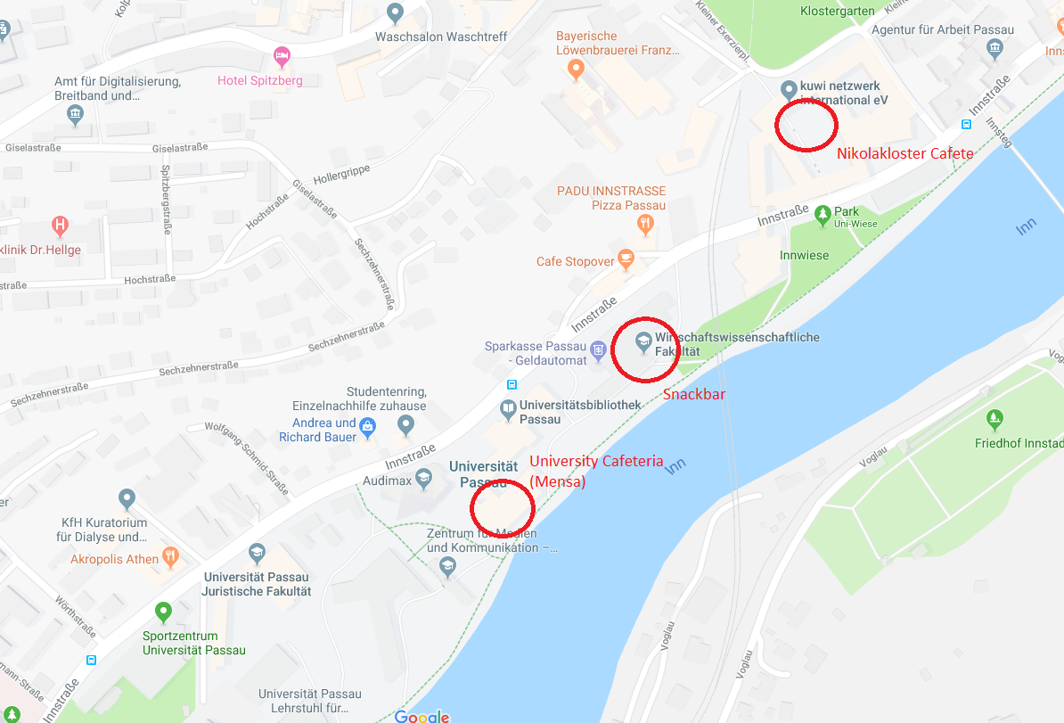

Hotels
Please make sure to book your accommodation as soon as possible. You can find a list of all available hotels, hostels and private accommodation featuring multiple languages HERE.

Transport
Everything is within walking distance in Passau’s city center. There are Taxis at the main train station, but we advise you to use the local bus infrastructure for larger distances. A single bus ticket costs 2€, however tickets for 8 rides (10€) and day-tickets (5€) are available at ticket vending machines or the bus driver. Refer to the VBP homepage (German) for information regarding the bus lines or contact us for help.

